Shipping Plan

Problem Description
In 2044 AD, humanity entered the cosmic epoch.

There are n planets in country L and n-1 two-way routes, each of which is established between two planets. These n-1 routes connect all the planets in L.

P is in charge of a logistics company. The company has many shipping plans. Each shipping plan is like this: there is a logistics ship that needs to fly from planet U_{i} to planet V_{i} along the fastest space path. Obviously, it takes time for a ship to travel through a route. For route j, it takes t_{j} time for any ship to travel through it, and there is no interference between any two ships.

To encourage scientific and technological innovation, the king of country L agrees to allow P’s logistics company to participate in the route construction of country L, that is, allow P to transform a route into a wormhole, and the spaceship will pass through the wormhole without consuming time.

Before the completion of the wormhole construction, P’s logistics company pre-connected M transportation plans. After the construction of the wormhole is completed, these m shipping plans will start at the same time, and all ships will depart together. When all the M shipping plans are completed, the stage work of P’s logistics company will be completed.

If P is free to choose which channel to transform into a wormhole, try to find out what is the shortest time it takes for P’s logistics company to complete the phased work.

Input
The first line includes two positive integers n and m, representing the number of planets in country L and the number of shipping plans pre-connected by small P. The planets are numbered from 1 to n.

The next n-1 lines describe the construction of the routes, where line i contains three integers a_{i}, b_{i}, and t_{i}, which means that the two-way route i is built between the two planets a_{i} and b_{i}, and it takes t_{i} time for any spacecraft to pass through it.

The next M lines describe the situation of the shipping plan, where the j^{th} line contains two positive integers u_{j} and v_{j}, indicating that the j^{th} shipping plan is to fly from planet u_{j} to planet v_{j}.

Output
There is an integer representing the minimum time it takes for P’s logistics company to complete the stage work.

Sample Input
6 3
1 2 3
1 6 4
3 1 7
4 3 6
3 5 5
3 6
2 5
4 5

Sample Output
11

Data Range
The range and characteristics of all test data are shown in the table below:
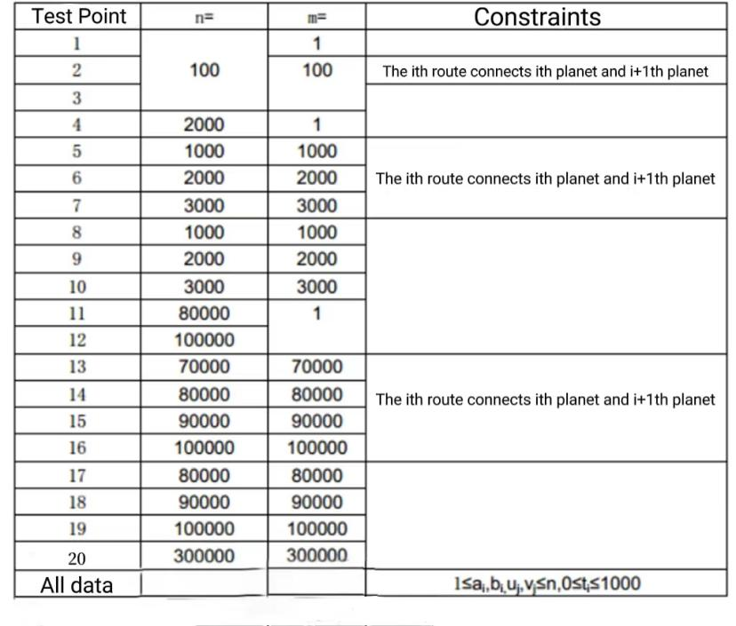
Be aware of the constant factor effect on program efficiency.

For 100% of the data, guarantee: 1 ≤ a_{i}, b_{i} ≤ n, 0 ≤ t_{i} ≤ 1000, 1 ≤ u_{i},v_{i} ≤ n.

